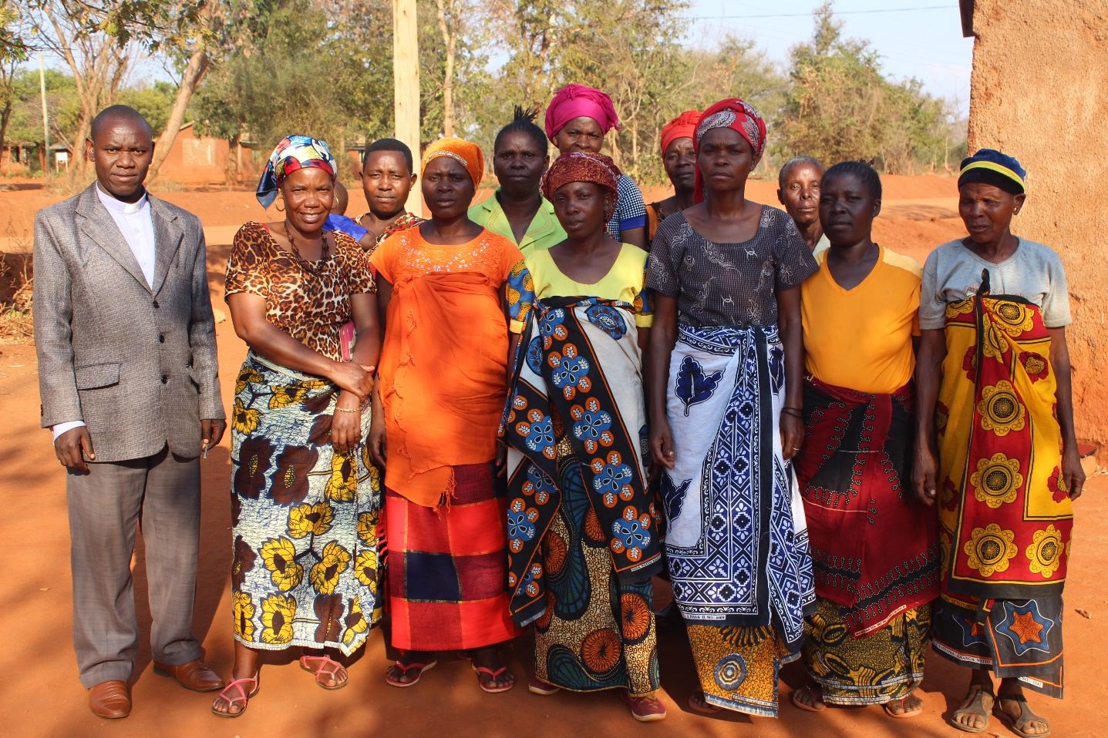
These women are part of Amani (meaning ‘peace’ in Swahili) Vicoba in the diocese of Central Tanganyika, Tanzania. The man on the left is the pastor of their church and is very supportive of the ways in which they have reached out to others. For example, the group has enabled these women to contribute regularly to the church offertory and take responsibility for church repairs to the church building. They also support community members by helping them to meet their basic needs including providing food and contributing to school fees for those who cannot afford to.
In their group, these women share God’s love, provision and peace with one another. As a result of their experience, they are encouraged to share that love, provision and peace with the wider church and the community. “Since joining the group I now have peace.”

